**DAILY ONLINE ACTIVITIES SUMMARY**

|  |  |  |  |  |  |  |  |  |
| --- | --- | --- | --- | --- | --- | --- | --- | --- |
| **Date:** | **07-06-2020** | | | | | **Name:** | **RACHANA K N** | |
| **Sem & Sec** | **6th  Sem ‘B’ Sec** | | | | | **USN:** | **4AL17CS070** | |
| **Online Test Summary** | | | | | | | | |
| **Subject** | | **SSCD** | | | | | | |
| **Max. Marks** | | **30** | | **Score** | | | **20** | |
| **Certification Course Summary** | | | | | | | | |
| **Course** | **DataScience Methodology** | | | | | | | |
| **Certificate Provider** | | | **IBM** | | **Duration** | | | **5hr** |
| **Coding Challenges** | | | | | | | | |
| **Problem Statement:3 programs** | | | | | | | | |
| **Status: done** | | | | | | | | |
| **Uploaded the report in Github** | | | | | **yes** | | | |
| **If yes Repository name** | | | | | **DAILY_STATUS** | | | |
| **Uploaded the report in slack** | | | | | **yes** | | | |

**Online Test Details:**

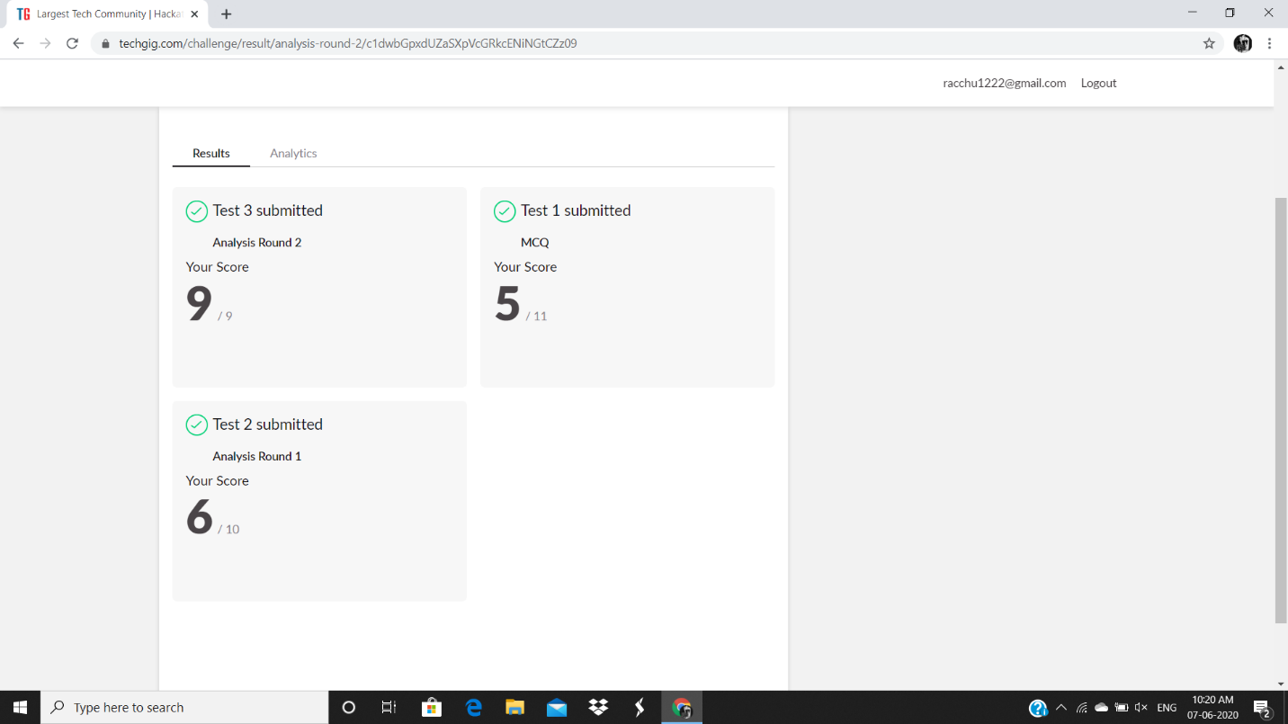

**Certification Course Details:**

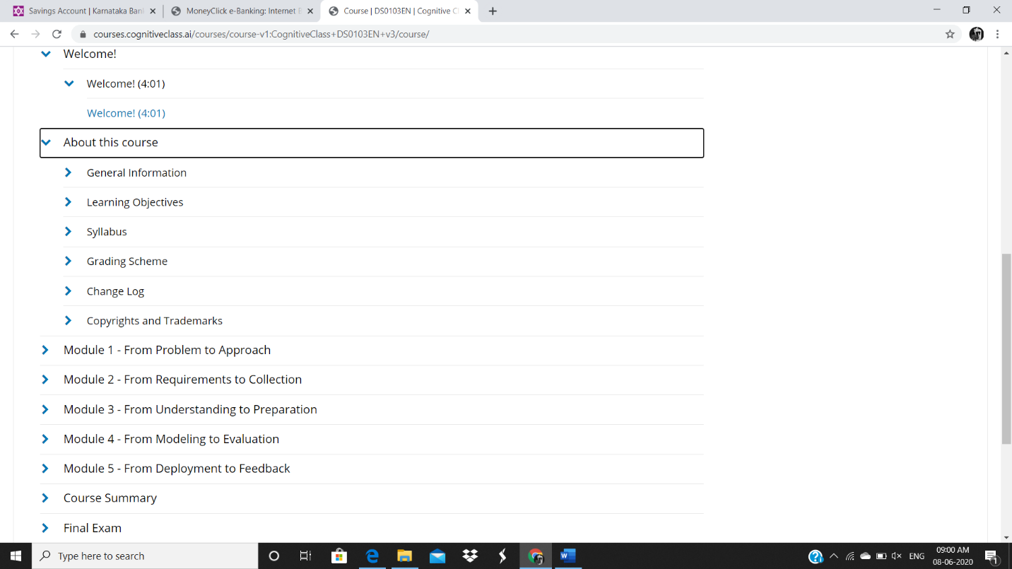

**Coding Challenges Details:**

Refer the github link for detail information : https://github.com/rachnarayan1201/daily_status_coding/commits?author=rachnarayan1201

Solved all the problems and the solutions are uploaded in github account.